Daniel Beck

SDEV-325

August 22, 2020

After creating a folder for the files, to execute C++ code, a file was created with the extension “.cpp”. To execute Java code, a file was created with the extension “.java”. To execute Python code, a file was created with the extension “.py”.

1. Screenshots of executed code

1. Executing “Hello World” with C++ in Cloud 9 environment
2. Executing “Hello World” with Java in Cloud 9 environment
3. Executing “Hello World” with Python in Cloud 9 environment

1a.

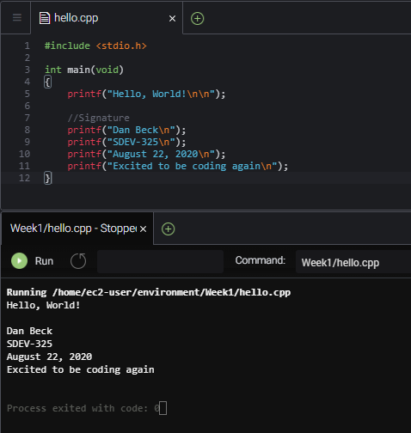

1b.

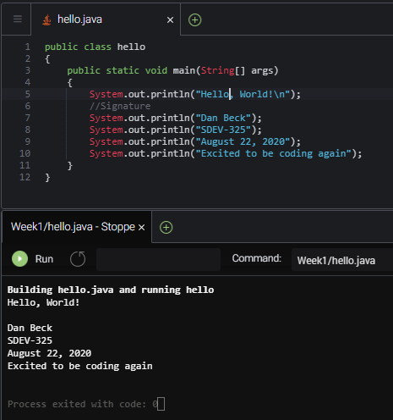

1c.

